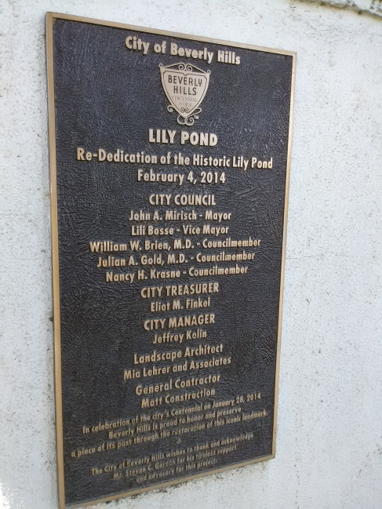
Decorations on the Lilly Pond
If great ideas hide in plain sight, it is obvious when non-profit innovates. Portraits of Hope has advertised the placement of decorations on the Lilly Pond in Beverly Hills during the summer month of August of this year. Glasses were handed out for viewing the event and a stroll around the pond was interesting. Roses surround the historic site and a city placard permanently describes the pond’s importance. An attendant handing out 3-D glasses, for effect, spoke briefly to me about the event and Literature was displayed along with a symbolic globe.
The globe was fenced off and a view of the Beverly Hills sign could be seen in the background from the western side of the event. The event was fun and I would like to see more of Portraits of Hope around the area, and elsewhere. A stroll through Beverly Hills leads a pedestrian here and there and I was happy to stumble across this event.

