A Feeling That Action Is To Come, Godzilla!
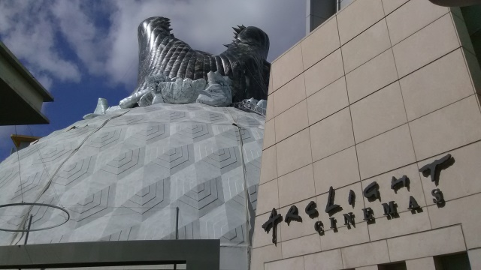
May 30th at 4pm, Godzilla: King of the Monsters will begin showing at the ArchLight in Hollywood. Memorabilia from various films, worn by the cast, sits behind a glass display and the board, with show times, is well-lit and huge in appearance. The attendant knew by heart the time of the first showing and guided me through the theater’s interface. We found the show times together and he described to me the option for 3-D and whether or not the showing had a documentary included. Outside, the Dome of the theater is well-decorated by a large lizard head and ‘what will this movie be about?’ is worth-asking. As I gazed upon this enormous object breaking through the Dome, I could not help but feel it would be an action movie.
