The Events and College Football
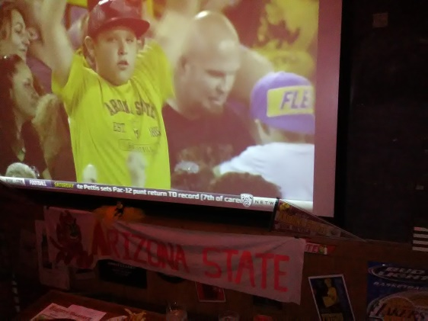
NCAA football was pastime worthy and a fun season that was full of events. The ASU alumni association provided several team-spirit events in Los Angeles and the local alumni were allowed to attend. Up to twenty people a game, sometimes more, watched on big screens and invitations were sent by email over the season. Arizona State University is a part of the Southern PAC -12 conference. USC and University of Arizona also belong in the southern conference. The teams played in Los Angeles Memorial Coliseum, which is south of downtown Los Angeles.
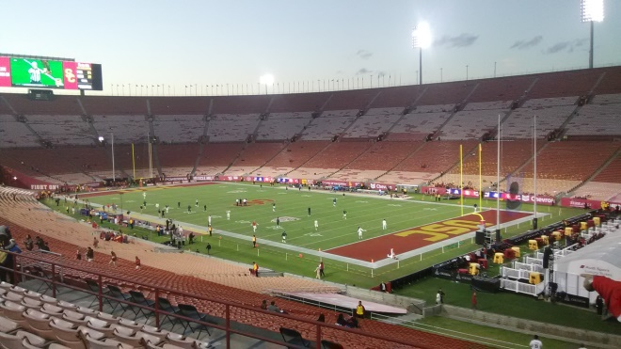
The sections began to fill in an hour and a half before kick-off along with practice, which started a half hour earlier. Fireworks took place at “sixty minutes till kick-off,” which took place ten minutes till 8pm. The USC Trojans blocked a punt early in the first quarter which resulted in a return and a touchdown. The University of Arizona Wildcats scored two field goals in the 2nd quarter and USC scored two touchdowns.
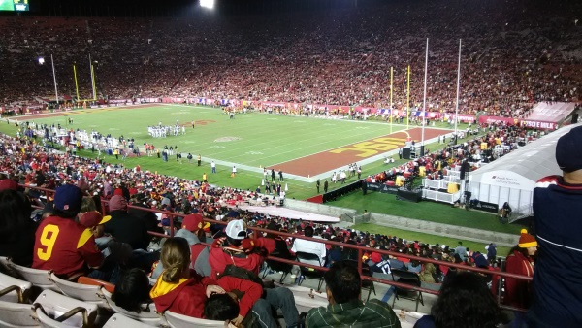
USC scored a touchdown first in the third quarter followed by two touchdowns by University of Arizona back to back. A Trojan mascot mounted on a horse rallied the crowd in the fourth and USC scored another touchdown followed by two University of Arizona touchdowns and a two point conversion which brought the game to (35-35). USC scored two more touchdowns in the fourth to win (49-35). Both teams ended up playing in NCAA bowl games according to ncaa.com.
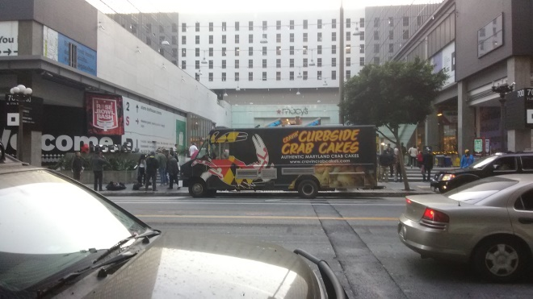
Another important NCAA bowl game was promoted downtown with a “Bash.” The Rose Bowl Bash took place the day before the game and the L.A. times covered the famous parade the day of the game, which took place in Pasadena. A crab cake truck was parked in front of Macy’s on 7th street and a free standing schedule of the event was placed in front.
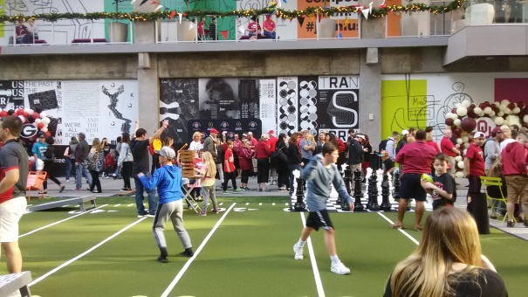
A small field where children tossed footballs was in the center of the courtyard and lawn chairs surrounded the field. A tent with Rose Bowl official merchandise was placed near descending escalators and an option to be photographed with a prominently displayed trophy was available.
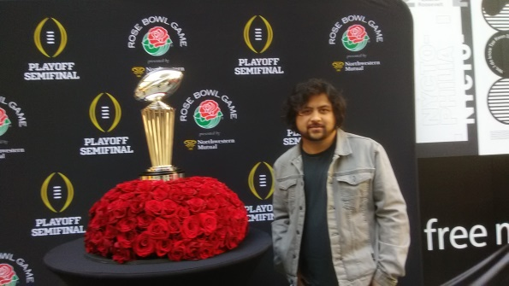
Two screens to the south of the field were placed as backdrops for a beer garden where permission was given to enter after an I.D. was presented. The D.J. was positioned above the field looking down at the event and five streamers stretched across the courtyard. Balloon shrines to the Georgia Bulldogs and the Oklahoma Sooners acted as photo opportunities and the game seemed to begin from there.
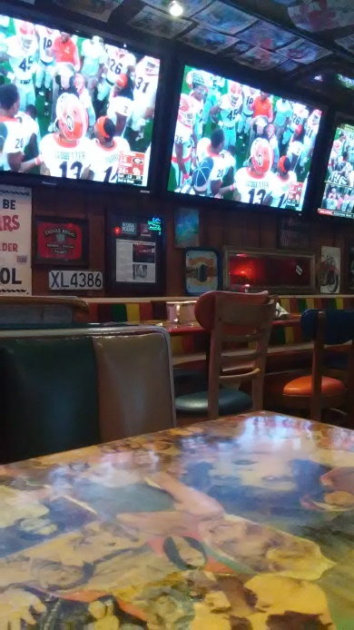
The Rose bowl between the Georgia Bulldogs and the Oklahoma Sooners began at 2:08pm the next day and the game was exciting to watch. I purchased one-iced tea and one beer at Barney’s Beanery in West Hollywood and continued to watch till the end of the game. Twelve screens in one dining room showed the game. Memorabilia, articles from over the years, and neon signs cover the walls and two pool tables are centrally placed. A breakaway touchdown in the third quarter by Georgia and a turnover touchdown return in the fourth quarter by Oklahoma highlighted exciting moments. Eventually, Georgia defeated Oklahoma in double overtime, (54-48).

