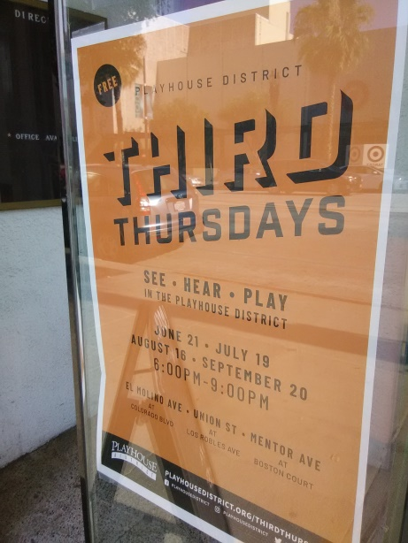
Current events in Pasadena were immersive and a pleasure to attend: “Third Thursdays: See.Hear.Play. In the Playhouse District.” A booth attendant directed me from El Molino Ave at Colorado Blvd., which is down the street from the Pasadena City Playhouse, towards Union St. at Los Robles Ave. where they were handing out free shaved ice to the first 100 people to attend. Picnic tables, with pillared tents, shaded pedestrians eating shaved ice from the heat and the museum next door was open to the public. A handful of non-traditional chairs were also placed in the parking lot for people to enjoy. The bottoms of the chairs were uneven and round, which made sitting an on-going, circular/angular experience.
After strolling through the museum’s enriching material, some of which was interactive through drawers that could be pulled from cabinetry, to observe the content inside, I sat in the museum’s central auditorium were three musicians sat at the foot of descending stairs which faced each other. Chairs where placed in the space provided and the show played for several dozen people. The musician’s took a break at 8pm at which time I began to record the remainder of the show through an audio recorder. One musician played cello, one played sitar, and the other play percussions from a seated position. The mixture of musical influence and the abundance of what the musician’s displayed, through brevity and informed discussion, swept through the evening with insight into music from elsewhere.
Pasadena was very hot and, though walking to the corner streets where the events took place was bearable, I was happy to sit. Music, free foods, and museum exhibits filled the evening with a sense of the city as host to patrons instead of pedestrians. The evening overall was worth waiting till the end of the event which concluded at 9pm.

