Regarding Opera and the Road Further: “The Abduction from the Seraglio”
Downtown is hilly and steep heading north. The LA Opera is one of many interesting venues and important shows in this area. The building, from floor to balcony, is imposing and full of décor. Once seated, conversation is enough to begin the next two and a half hour journey aboard the Orient Express.
The Abduction from the Seraglio was worthwhile though it could be confusing at times. There are very beautiful moments when the affections of those involved in two love triangles become obvious. When Blonde and Pedrillo declare their affection alongside Konstanze and Belmonte, while the stage is split between two scenes, the opera reaches a richer depth. However, the comedy involved in developing the plot moves the piece forward. Osmin is extremely funny and Pedrillo’s slapstick inventions serve the plot more than the confusion of love that surrounds Konstanze and Blonde.
The romance of travel from Istanbul to Paris is exciting and successful. A large teleprompter above the stage projects English lyrics and the stage was tightly fit together. Intermittently, a large map tracks the progress of the Orient Express and the passengers struggle to come together from there.
Throughout the two and a half hour show, there are points when the orchestra is transformative and breathtaking. The conductor James Conlon’s pre-opera conversation, his thoughts in understanding Mozart’s deeper concerns, help the audience connect with Mozart. To understand James Conlon’s choices as a conductor would aid a member of the audience as much as understanding the composer’s genius. The comedy’s romantic moments are enriched by Mozart’s creativity and depth in music composition.
The opera was important and I will be attending more. Two and a half hours can be a plunge but such a strong impression raises further concerns over the depth of such an immersive experience. A lot can be said in a single show. I would not go further as a patronizing citizen without wanting to know more of opera and the journey aboard its expanding horizon.
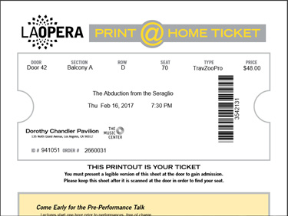
https://www.laopera.org/news/Gallery/201617-Season/Abduction/

