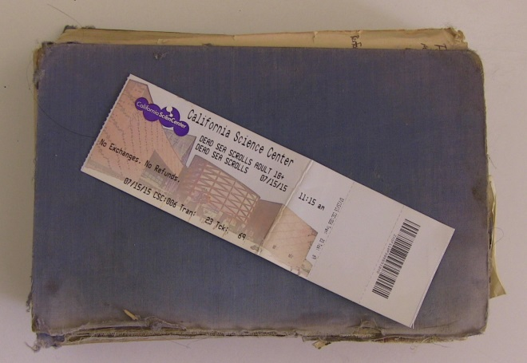
The Skin of the Dead Sea Scrolls
By Brandon Lund
A museum for most people is a place where learning through an immediate encounter with something rare is expected. The glassy thoroughfares, the collections each asking for attention from an audience, oftentimes give way to a perspective that is closer to a handshake than a classroom. The Dead Sea Scrolls create an immediate understanding that is unique because the audience is no longer reading about history they are observing history from its inception. Perhaps the richest and most rewarding aspect of the Dead Sea Scrolls is the biblical context.
Twelve Psalms from the Bible, written on animal skin in Hebrew, can be observed alongside portions of Exodus. The handwriting, the detail and implied skill, begins to humanize and focus their creation. Most people spend their entire lives struggling with notions of hereafter, death, reward of life, and morality; to stand within a respective step of an original piece of animal skin inscribed with biblical text and see the ancient scribes handwriting begins to create a sense of moving forward. These biblical prayers, poems, and narratives do have their origins.
Leading to the room-size circular glass display showing pieces of Scripture and parchment is a series of Iron Age arrowheads and water jugs. The character of these pieces is obvious. The arrowheads speak of need and hunger. The rust showcases their fragility but their age begins to reveal a world that was perhaps dangerous in many ways that the audience does not understand without further study. The displays are not exactly art but the humanity involved in their creation is obvious.
Creativity tends to hold a person’s focus and one cannot help but feel that these bronze-age coins and ancient water jugs were created for aesthetic purposes instead of utility. A Galilean Pithos with delicate fissures and threads of age that have endured stares at the viewer like a totem. The apparitional affect is theatrical and one cannot help but feel the desert’s withering heat lifting from these ancient pots and coins.
The Dead Sea Scrolls, showcased at the California Science Center, was short but the experience was not without its high points. The little tiny pieces of text, sometimes biblical sometimes non-biblical, begin to create the effect of people involved in the creation of history. Their presence is ghostly and their priorities range from poetry to narrative wisdom. I do recommend the experience but perhaps historical impact and not the duration of the tour is the strong point of the venue.

