Pleasantly Surprised by the Year to Come

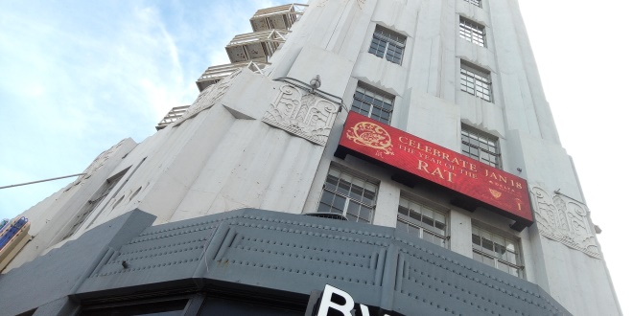

Developments in Beverly Hills are beginning to become increasingly important as Los Angeles, and elsewhere, celebrate the Chinese New Year. Promotional material has been placed along thoroughfares and ticketed events make the month of January interesting.
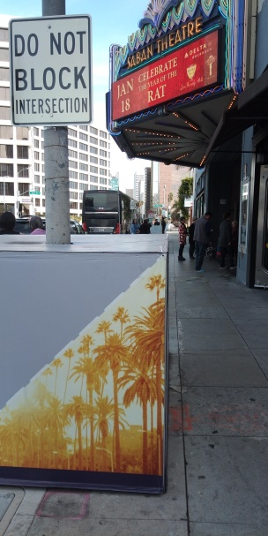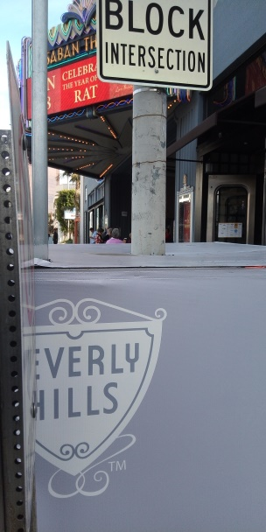
On Wilshire, in Beverly Hills, the Sabean Theater celebrated the Chinese New Year through music and theater. In the lobby, lanterns hung in the circular lobby and free standing literature described the show that was to come. After entering, to the left, an artist created small sculpted art with scissors and paper.
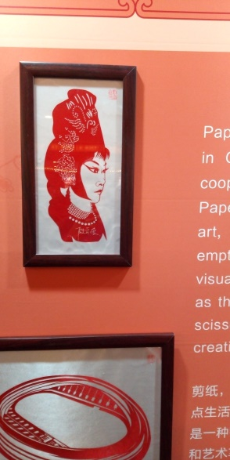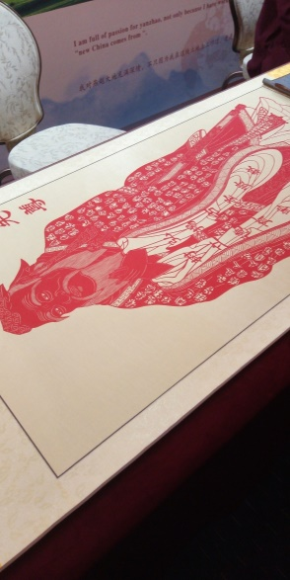
Description of important developments into this art where mounted on the walls and the wait was also interesting. An annual passport for the show was given out to those who asked and everything seemed well-explained.
The show opened up with choreographed music and then developed through dance and historical drama. The artistic interpretation of a drunken boxer was worth remembering along with solo artists and larger acts that required multiple performers. Popular music along with ethnic minorities of China developed the show and delivered what was a complete and entertaining event.
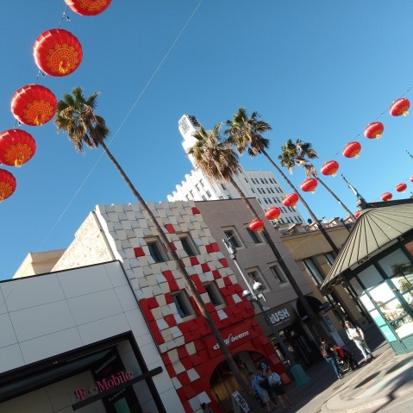
Wanting to know more of the Chinese New year after the show concluded, I found myself pleasantly surprised to find the same lanterns hanging in the 3rd St promenade in Santa Monica. From there, I found a great view and celebrated the year of the Rat with a drink on a quiet Sunday while thinking of the year to come.

